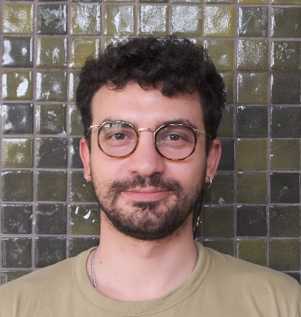

**Ali Alparslan | *Game Developer***

*ANKARA, Turkey, +905067479152*[*ali.alparslan.94@outlook.com*](mailto:ali.alparslan.94@outlook.com)

**LINKS** Website: [donchokella.github.io](https://donchokella.github.io/index.html)

Itch.io: [donchokella.itch.io](https://donchokella.itch.io/)

Github: [github.com/donchokella](https://github.com/donchokella?tab=repositories)

LinkedIn: [linkedin.com/in/alialparslan](https://www.linkedin.com/in/alialparslan/)

**PROFILE** I graduated from the **Middle East Technical University** (METU) with a degree in **Civil Engineering**. After graduating, I started working on game development. I have been actively involved in **METU GATES** (Game and Animation Technologies Society) for a while. I am ready to take a step forward and continue my journey in an environment that challenges me every day!

**EDUCATION**

*Middle East Technical University* BSc. Civil Engineering  
*Jun 2021*

**SKILLS** C# Unity GitHub Aseprite

HTML CSS JS

**LANGUAGES** English, *full professional proficiency* Turkish, *native*

**COURSES**

*Udemy* Unity 3D Temel C# ve Doğru Kodlama Eğitimi – Berk Terek  
*Aug 2023*

*Unity Learn* Junior Programmer Pathway *Apr 2023*

*W3schools* C#  
*Jan 2023*

*Harvard University* CS50's Introduction to Game Development  
*Sep 2022*

*Harvard University* CS50's Introduction to Computer Science  
*Mar 2022*